Acknowledgment

I would like to thank North South University and its faculty members for teaching me so much that I can finally write my thesis paper. I especially thank faculty members for teaching us the intricacies of research paper writing. I am forever grateful to the Department of Electrical & Computer Engineering for teaching me everything.

Abstract

This research aims to investigate students’ use of artificial intelligence (AI) tools for plagiarism. AI is the latest invention of humanity. Unsurprisingly, it comes with perks and chaos. Currently, no academy acknowledges AI plagiarism as it is new. So, there are no rules and regulations to control students’ engagement in plagiarising mischief. This research tries to find students’ insight from within and their motivation to deal with this problem. It surveyed many enrolled students, taking their honest opinions and contributing to qualitative research. For quantitative research, it studies many recent newspaper articles about this issue. I am a computer science and engineering student, and my electives, projects, and research were all about the development of AI. As a result, I am apprehensive about its misuse. By conducting this research, I have concluded that students are conscious of their evil deeds. As a result, plagiarism has not increased overall, but it is now easier to commit. With the help of AI detection tools, academies worldwide can fight this problem without any hassle. By providing these detector tools and enforcing relevant penalties, the education system can finally see the good use of AI. For example, they can generate study materials that otherwise would cost them money by buying books and PDFs. It may also reduce piracy.

**Keywords:** AI, Chatgpt, AI detector, Turnitin, generative AI, ethics, copyright.

Table of Contents

Page no.

Acknowledgement--------------------------------------------------------------------------------------------2

Abstract---------------------------------------------------------------------------------------------------------3

1 Introduction----------------------------------------------------------------------------------------------6-10

1.1 Background---------------------------------------------------------------------------------------------6-7

1.2 Research Focus-----------------------------------------------------------------------------------------7-8

1.3 Overall Research Aim---------------------------------------------------------------------------------8-9

1.4 Individual Research Objectives---------------------------------------------------------------------9-10

1.5 Timetable ------------------------------------------------------------------------------------------------10

2 Literature Review--------------------------------------------------------------------------------------11-12

2.1 Introduction----------------------------------------------------------------------------------------------11

2.2 Previous Studies-------------------------------------------------------------------------------------11-12

3 Methodology-------------------------------------------------------------------------------------------13-15

3.1 Primary Data Collection Technique-----------------------------------------------------------------13

3.2 Design of the Questionnaire-----------------------------------------------------------------------13-14

3.3 Secondary Data Collection Technique--------------------------------------------------------------14

3.4 Nature of this study---------------------------------------------------------------------------------14-15

4 Results and Discussions------------------------------------------------------------------------------16-32

4.1 Data Presentation & Analysis-------------------------------------------------------------------------16

4.2 Summary of Research Findings-------------------------------------------------------------------16-32

4.2.1 Biographical Information------------------------------------------------------------------------16-17

4.2.2 Primary Data---------------------------------------------------------------------------------------17-31

4.2.3 Summary of research findings-------------------------------------------------------------------31-32

5 Conclusion----------------------------------------------------------------------------------------------33-34

5.1 Summary-------------------------------------------------------------------------------------------------33

5.2 Value of this Study--------------------------------------------------------------------------------------33

5.3 Limitations of this Study-------------------------------------------------------------------------------34

5.4 Recommendations---------------------------------------------------------------------------------------34

6 References----------------------------------------------------------------------------------------------35-36

7 Questionnaire------------------------------------------------------------------------------------------37-41

Chapter 1: Introduction

# 1.1 Background

AI has been a hot topic for the last two years. With the introduction of Chatgpt, AI has integrated unconsciously into our daily lives. It is one of the most popular Generative AI applications. Generative in this context means generating texts, pictures, music, and videos. But generation doesn’t mean creation but mixing and matching other people’s works! This aspect is unknown to all, and as a result, people are thinking they are generating unique content with AI. Consequently, the act of plagiarism comes to life.

Students are the most affected by this plague. Students always search for an easy way out. They think that this is some kind of magical tool that has a brain. But little do they know plagiarism checkers have also evolved to match AI. Therefore, they somehow hurt students’ creative capabilities. Too much automation is making the machines lively and us the robots. Habib et al. (2024) explore the roles of AI in creativity. They depict how it negatively impacts students' creativity and suggest a careful approach.

Turnitin is one of the detection software to fight plagiarism. As Chatgpt came, it evolved to match the fight. This kind of war never ends—one upgrades, and the next day, the other upgrades even more. The work of students and teachers has increased amidst these. Sometimes, students spend all their days plagiarising and exploiting hacks. Boser (2024) explores the ways how AI detectors work.

On the other hand, teachers are also getting frustrated reading these robotic homework and giving them penalties to the fullest. Nobody is winning here, but the two mentioned software companies. Topinka (2024) cites a sad story of a teacher facing a dilemma regarding whether to trust Turnitin or one of her favorite students when the software marked an assignment as plagiarized. Similar incidents are happening all around the world.

Fore (2023) argues that AI might help accessibility to education, but it promotes cheating and plagiarism. As with all the inventions, there are always two sides. It is we, the academics, that must explore the good ways to make use of this latest invention of humanity. As with gun control laws, they are the most effective ones. We can say the same about AI tools, too. Law enforcers should come forward to tackle copy-writes and plagiarism penalties. Morgan (2023) says a precious thing, i.e., to teach students how to use AI tools rather than focusing on punishing. By learning AI usage, students can benefit. According to Singleton (2024), AI has seen minor usage but only hype.

# 1.2 Research Focus

The research questions are below:

* Why and how do students use AI?
* Are students depending more on AI than learning nowadays?
* Are AI applications and the services they provide for students trustworthy?
* Is AI helping students learn creative thinking or harming their creative capabilities?
* If a student uses AI for homework, do you think it is cheating?
* What do you think about AI generating copyrighted content?
* To what extent can AI-generated content be modified to become acceptable?
* Do you think AI and professionals deserve equal paychecks?
* Do you prefer AI or professionals to do your creative tasks?
* Would you co-author an AI tool if you take its assistance?
* What legal laws should you introduce for all these controversies related to AI plagiarism?

# 1.3 Overall Research Aim

AI hurts students’ creative capabilities. AI is today's most controversial topic, especially among academics. It is like the new calculator, which is helpful, but we must remember basic arithmetic. Various ethical and legal controversies arise from AI usage. Among them, creative capabilities strike the most. These so-called mechanical brains are performing creativity at the best human level. But are we ready for such advancements?

Nowadays, students get AI aid and complete their assignments without looking at the AI-generated work. One cannot argue against its hurting of creative capabilities. Students are depriving themselves of actual learning by using it to cheat and plagiarize. AI detectors cannot detect all the AI generations. Moreover, not all academia can access AI detection software subscriptions as they are too expensive. Sometimes, students spend a colossal time finding these vulnerabilities rather than studying. They should utilize those times in education, not in immoral ways.

Not all teachers have been familiar with AI plagiarism. Academia lacks penalization rules. As a result, teachers face harsh situations about whether to give students assignments or not to follow old curriculums. Without penalization rules, the mark deduction rate is not constant among all the teachers in the same academy, which is a headache for students across the globe. Sometimes, they are penalized without committing anything because of technical errors in AI detection systems.

Humanity invented generative AI to generate creative content that requires new ideas. Therefore, students learning creativity in academia are the most vulnerable. As this is a new topic, we need to enforce regulations. Only after that can humanity fully utilize this tool in unexpected ways that are unknown today. Marrone et al. (2022) researched how classrooms can integrate AI. It qualitatively analyzed how AI and creativity correlate. They argued that AI can never reach human creative levels. According to them, attentive students tend to be positive, and weak students fear AI tools.

Believe it or not, AI is a tool of academia. We all know that calculators are mandatory for students in there. How is AI different from a calculator? It is a vast topic. When calculators first came, humanity feared we would forget mathematics by hand and rely on machines. However, this tool is an academic's best friend after many regulations and discipline. The same story goes for computers, too. The AI story would not be any different.

# 1.4 Individual Research Objectives

The main goals of this research are below:

* Normalize AI tools and AI plagiarism.
* Familiarize teachers and students with AI and AI detectors.
* Get insight into student’s plagiarism acts using AI tools.
* Get student’s views of AI tools.
* Get student’s ethics about cheating with this tool.
* Get in-depth, first-hand suggestions on how to tackle this problem.
* Get a global view of this issue.
* Explore the ways how reputed universities and schools are tackling this issue.
* Propose AI regulations and control.
* Propose AI plagiarism regulations and control.
* Propose systematic considerate penalties for students.
* Explore good aspects of generative AI.
* Embrace AI.

# 1.5 Timetable

The timetable of the research is below:

| **Activities** | **Duration (In weeks)** | **Month** |
| --- | --- | --- |
| Introduction | 1 Week | April |
| Literature Review | 1 Week | April |
| Methodology | 1 Week | May |
| Results and Discussions | 2 Weeks | May |
| Conclusion | 1 Week | May |
| References | 1 Week | June |

Chapter 2: Literature Review

# 2.1 Introduction

This section discusses two of the most important pieces of literature found on the internet regarding AI plagiarism that directly correlate to my hypothesis. They are both from The Guardian.

# 2.2 Previous Studies

Vaidhyanathan (2023) found that students are cheating using AI. She portrays how AI can bring havoc to our lives. The news article mentions that this is familiar. Plagiarism has come in many forms, and teachers have dealt with it all their lives. She points out that the contents the AI tools generate are of poor quality, and humans can easily detect them by reading. They contain silly errors. She mentions that learning how the human mind and machine work is an excellent opportunity. She is curious about why we tend to compare these two. She noted that “I will require in-class writing” and “I will also assign more group presentations” to battle AI plagiarism (para. 15).

Marshall (2023) discusses how the threshold between AI and human-created content is diminishing daily. He illustrates how AI and AI detectors are at war and why human creativity is becoming shallower daily. He mentions the intricacies of AI detector software such as Turnitin and others with great accuracy. He showed how, with the invention of large language models like Chatgpt, schools face plagiarism challenges for tasks like essay writing and art projects. According to him, AI detector software is the most beneficial in this context, especially with the subscription they sell.

Chapter 3: Methodology

# 3.1 Primary Data Collection Technique: Survey

For the primary data collection, I used the survey technique. As AI is a very complex topic and most students need to become more familiar with it or all of its aspects, it is better to survey. This way, they will get sufficient time to think deeply and properly. The interview is also a great technique, but the topic has to be very familiar, which is different here—also, the questionnaire involved confessions of cheating and plagiarism.

According to Singer (2023), statistics show that AI didn’t increase cheating in high schools. This study used a lot of survey techniques. It is evident that for data collection involving confession, it is generally better to do a survey rather than an interview. Therefore, the online survey using Google Forms provided the necessary privacy to answer anonymously.

# 3.2 Design of the Survey Questionnaire

The first close-ended question, “Have you ever plagiarized homework by using AI and got away with it?” is to gain statistics. The second one, “Has overall student plagiarism increased after AI came?” is about the motive behind these statistics. The next one, “Do you agree that AI hurts students’ creative capabilities?” is about confirming the research hypothesis directly from the participants without any inferencing. The fourth close-ended question, “Can students increase their creativity by utilizing AI somehow?” is about fact-checking. After that, the three close-ended questions, “Do you agree that additional class tests should replace homework?”, “Do you agree that students’ homework should become classwork to avoid AI plagiarism?” and “Do you agree that universities should teach ethics related to AI usage?” are about finding possible solutions. The final one, “Should students use AI at all?” is to conclude with an opinion.

The first open-ended question, “Is it appropriate to penalize students for AI plagiarism? If so, then please mention to what extent and why.” is about an ethical dilemma. The final open-ended question, “Please suggest some good rules to fight AI plagiarism in universities.” is also about finding possible solutions.

# 3.3 Secondary Data Collection Technique

For the secondary data, I looked into The Guardian, Journal of Creativity, Journal of Intelligence, Fortune, The New York Times, Forbes, Wired, Times Higher Education, and BBC News. I collected all of these from the internet’s Google search using AI-related keywords like “AI plagiarism,” “AI cheating,” “AI copy-write,” and others. I only looked into good, reputed providers to get accurate information. They helped me answer my research questions and confirm my hypothesis. I have critically analyzed these secondary sources in the previous literature review, chapter 2.

# 3.4 Nature of this study

The nature of this study is both qualitative and quantitative research. Its qualitative part is more significant than the quantitative part because of the scarcity of information on this recently created topic. The information related to AI and its usage for plagiarism is mostly from news articles. On the other hand, enrolled students showed great enthusiasm in filling out the survey form and answering the open-ended questions to a great extent. It confirms that they are very bothered by this current issue. They hope our university will enforce new ethical rules regarding AI plagiarism in the code of conduct.

Chapter 4: Results

# 4.1 Introduction

I used Python programming to plot the graphs to illustrate my primary research data. I used two simple functions to generate all the pie charts and the word clouds. I made the pie charts based on participants' closed-ended answer percentages and word clouds based on word frequency in the open-ended answers. This way, the results can confirm the validity of my hypothesis nicely. Next, I will check for the validity of my hypothesis in each piece of data.

# 4.2 Description of results

## 4.2.1 Biographical Information

I mainly relied on primary research. I could manage 22 participants in total from three different universities. They are all enrolled bachelor students, so they know about AI plagiarism. Among them, 20 are from North South University (NSU). One is from Bangladesh University of Business and Technology (BUBT), and the other is from Jahangirnagar University (JU). Twelve students are female, and ten are male. None of them identified as “Other.”

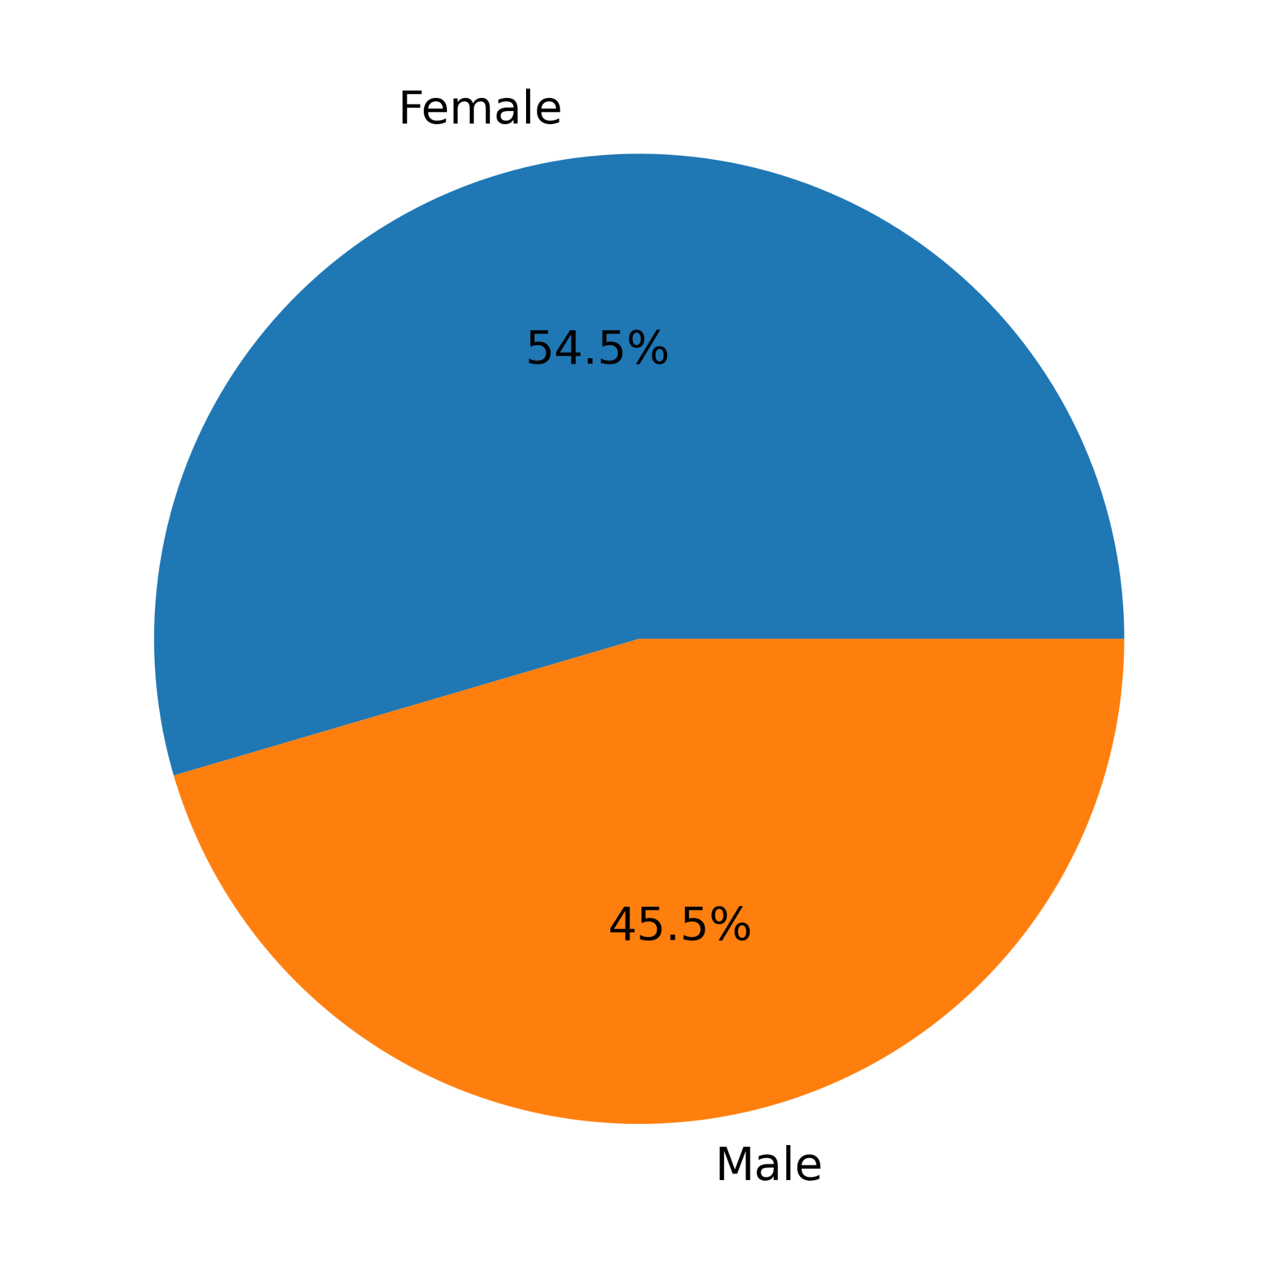

Figure 1. Pie chart statistics of participants' gender.

## 4.2.2 Primary Data

My first close-ended question was, “Have you ever plagiarized homework by using AI and got away with it?” The pie chart below shows that half of the participants confessed. They are indeed hurting their creative selves and are conscious to confess regretfully.

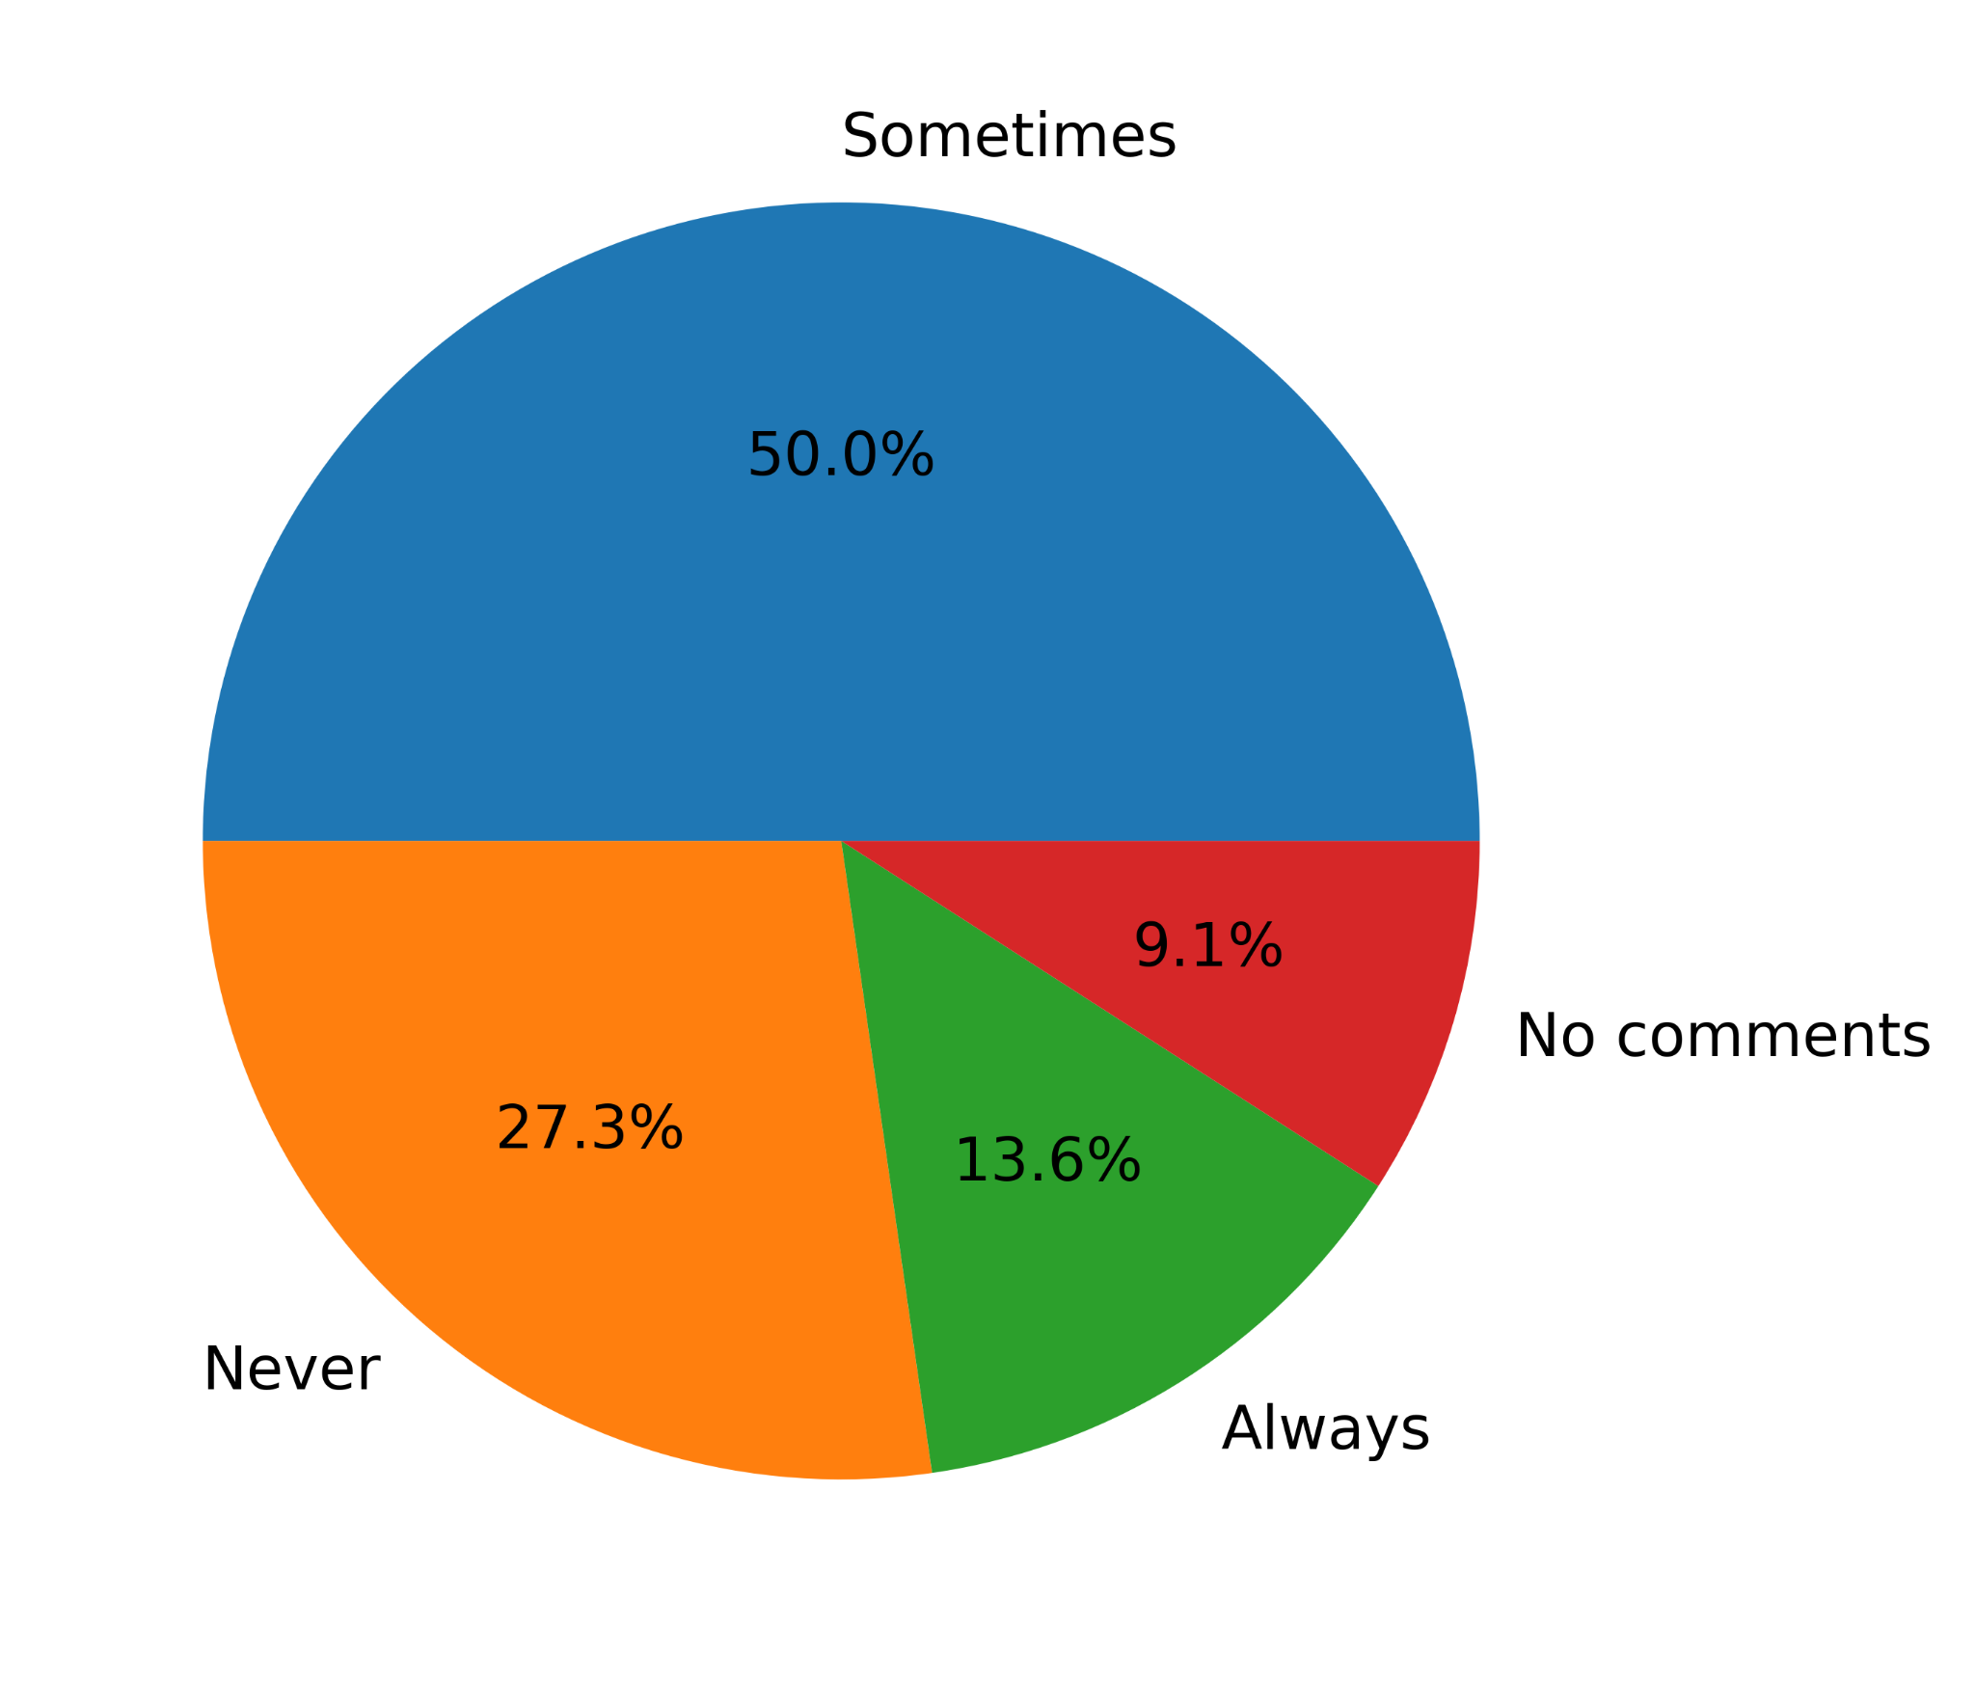

Figure 2. Pie chart statistics of the first close-ended question.

My second close-ended question was, “Has overall student plagiarism increased after AI came?” Half of the participants answered that plagiarism has “Increased,” and almost the other half further responded that it is still “Increasing rapidly.” None of them chose “Decreased” or “Decreasing rapidly.”

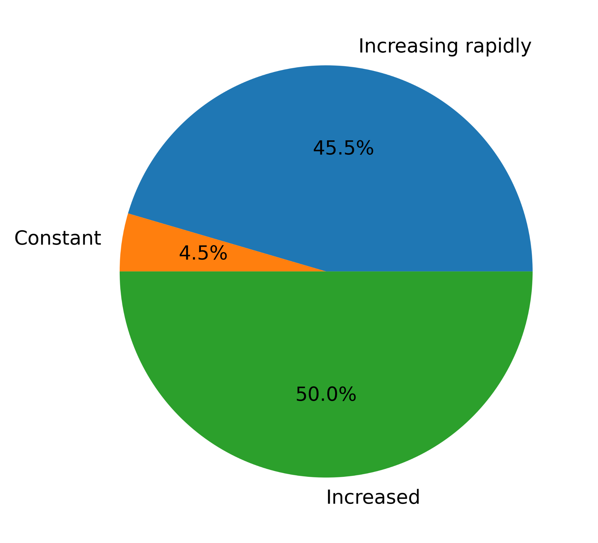

Figure 3. Pie chart statistics of the second close-ended question.

My third close-ended question was, “Do you agree that AI hurts students’ creative capabilities?” It is the hypothesis itself. The pie chart shows the majority “Strongly agree,” followed by “Yes.” On the other hand, 22.7% chose “Neutral”, and only 4.5% chose “No.” None of them decided “Strongly disagree,” which illustrates the participants' diversity of opinions.

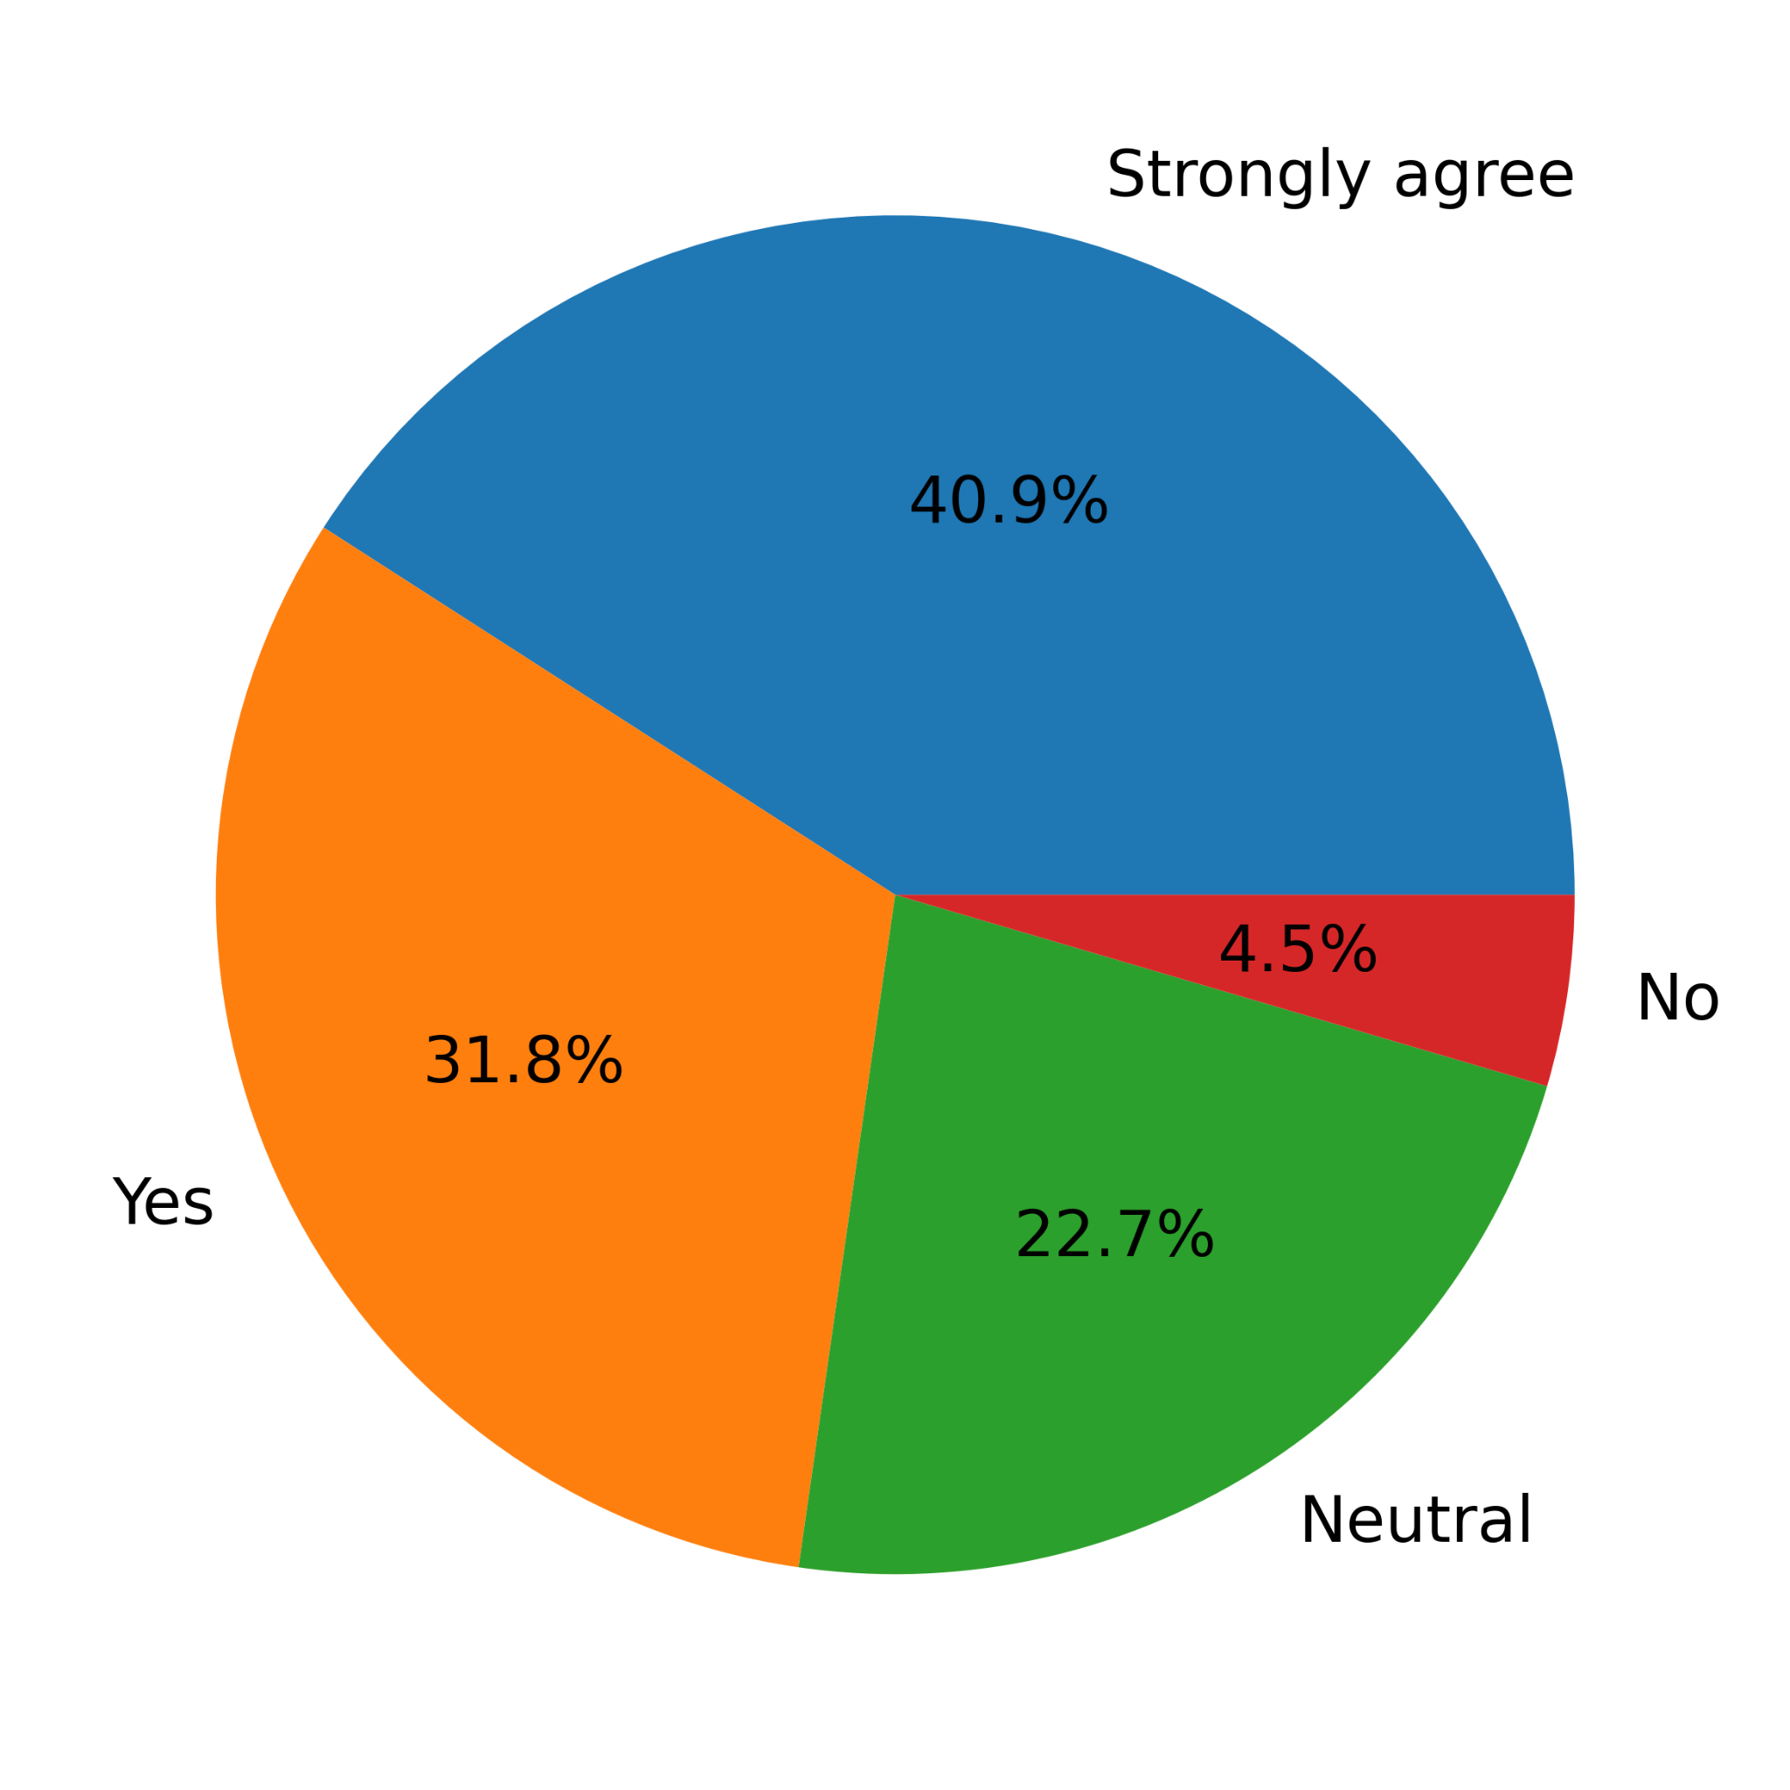

Figure 4. Pie chart statistics of the third close-ended question.

My fourth close-ended question was, “Can students increase their creativity by utilizing AI somehow?” Most of them chose “Sometimes,” followed by “Always.” Only 9.1% chose “Never.” None of them decided, “No comments.” This data illustrates the potential of AI tools other than plagiarism.

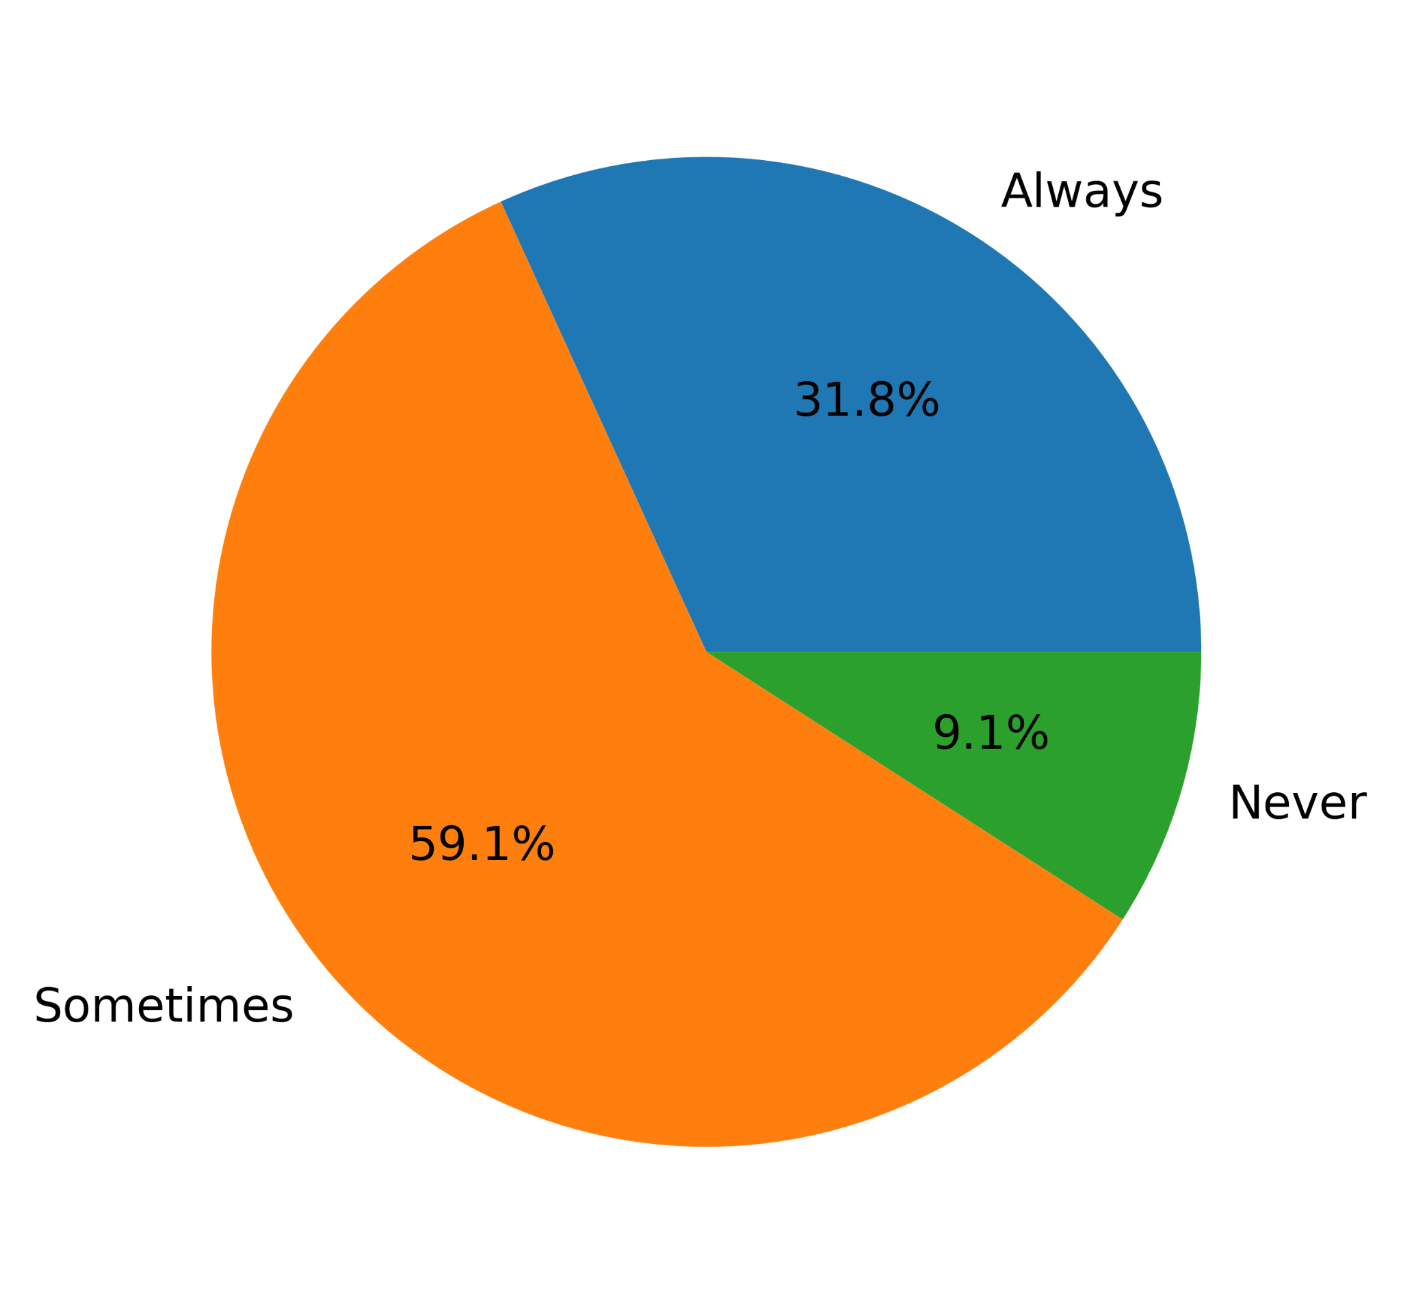

Figure 5. Pie chart statistics of the fourth close-ended question.

My fifth close-ended question was, “Do you agree that additional class tests should replace homework?” The answers are diverse. The majority, i.e., 31.8%, chose “Yes,” and 27.3% chose “No.” “Strongly agree,” “Neutral,” and “Strongly disagree” are all 13.6%. This data acknowledges the side effects of AI and suggests a solution for it.

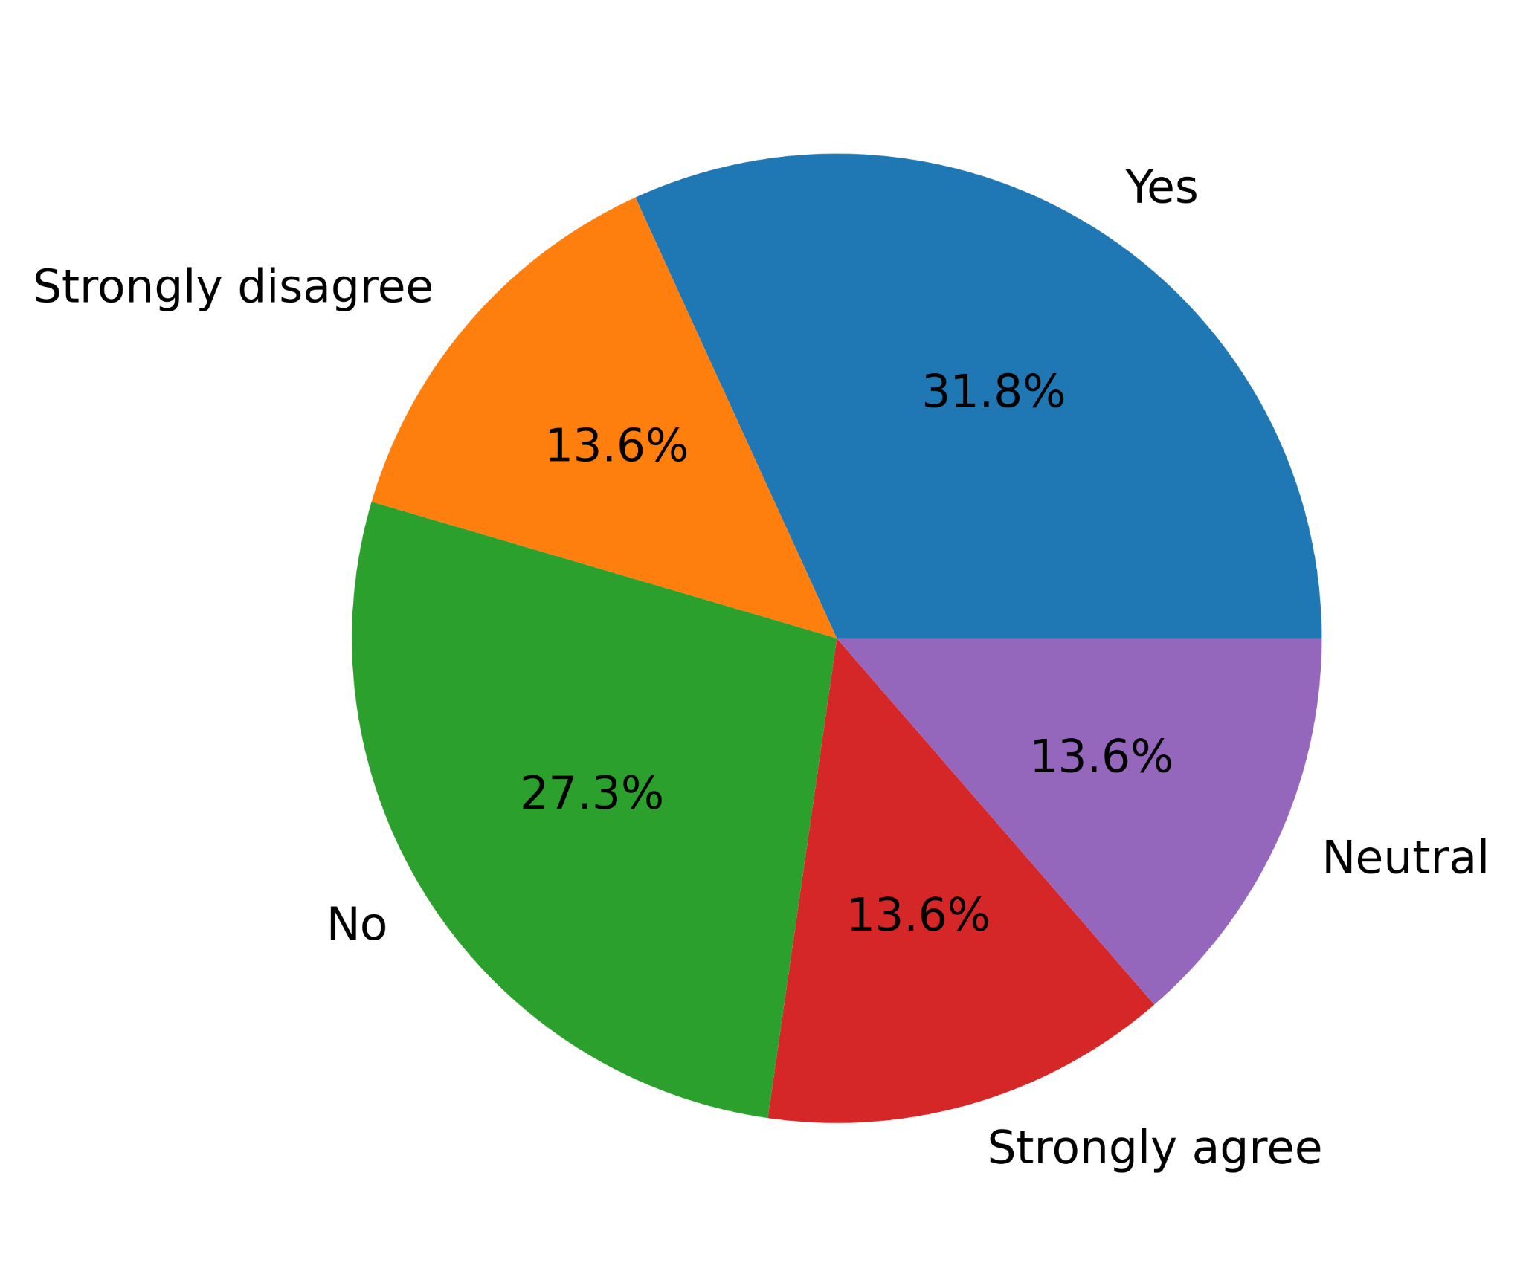

Figure 6. Pie chart statistics of the fifth close-ended question.

My sixth close-ended question was, “Do you agree that students’ homework should become classwork to avoid AI plagiarism?” The answers are once again diverse. The majority, i.e., 36.4%, chose “Agree,” and 22.7% chose “Disagree.” “Neutral” is only 13.6%. None of them decided “Strongly disagree.”. This data also acknowledges the side effects of AI and suggests another solution.

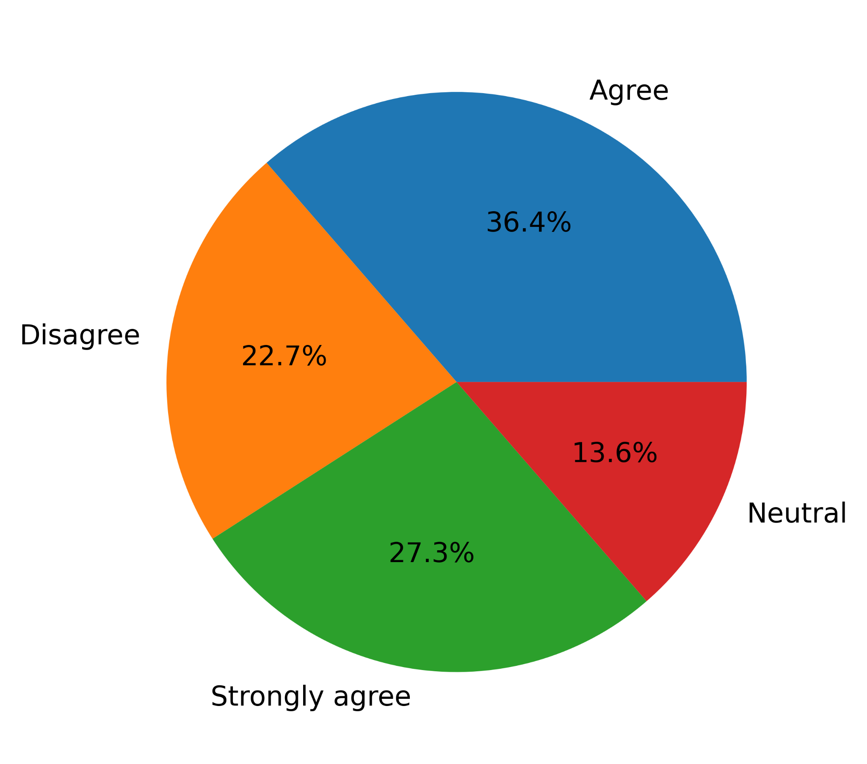

Figure 7. Pie chart statistics of the sixth close-ended question.

My seventh close-ended question was, “Do you agree that universities should teach ethics related to AI usage?” The answers “Agree,” “Strongly agree,” “Neutral,” and finally, “Disagree” are in the order 40.9%, 36.4%, 13.6%, and 9.1%, respectively. None of them chose “Strongly disagree.” This data proposes a logical prevention.

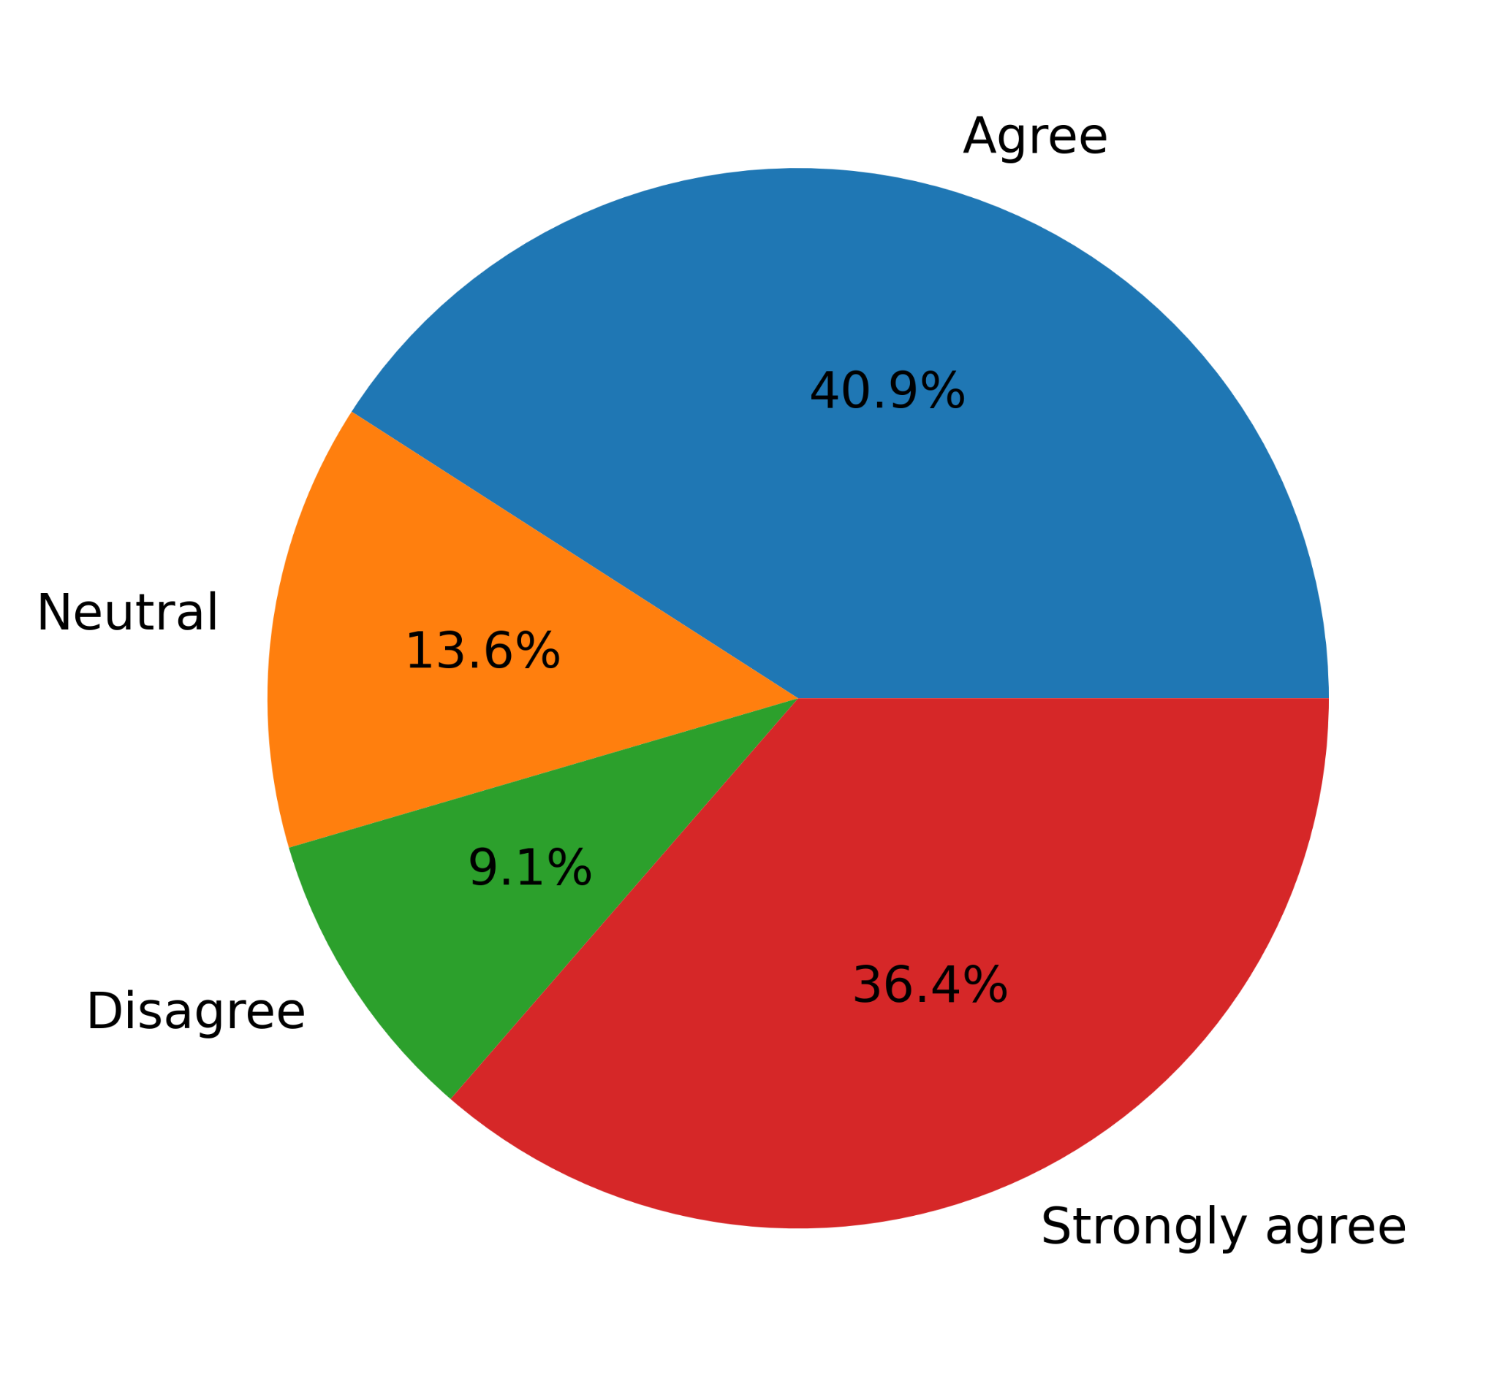

Figure 8. Pie chart statistics of the seventh close-ended question.

My concluding eighth close-ended question was, “Should students use AI at all?” The majority, i.e., 81%, chose “Sometimes,” followed by 14.3% of “Always.” 4.8% chose “Never.” None of them decided, “No comments.”

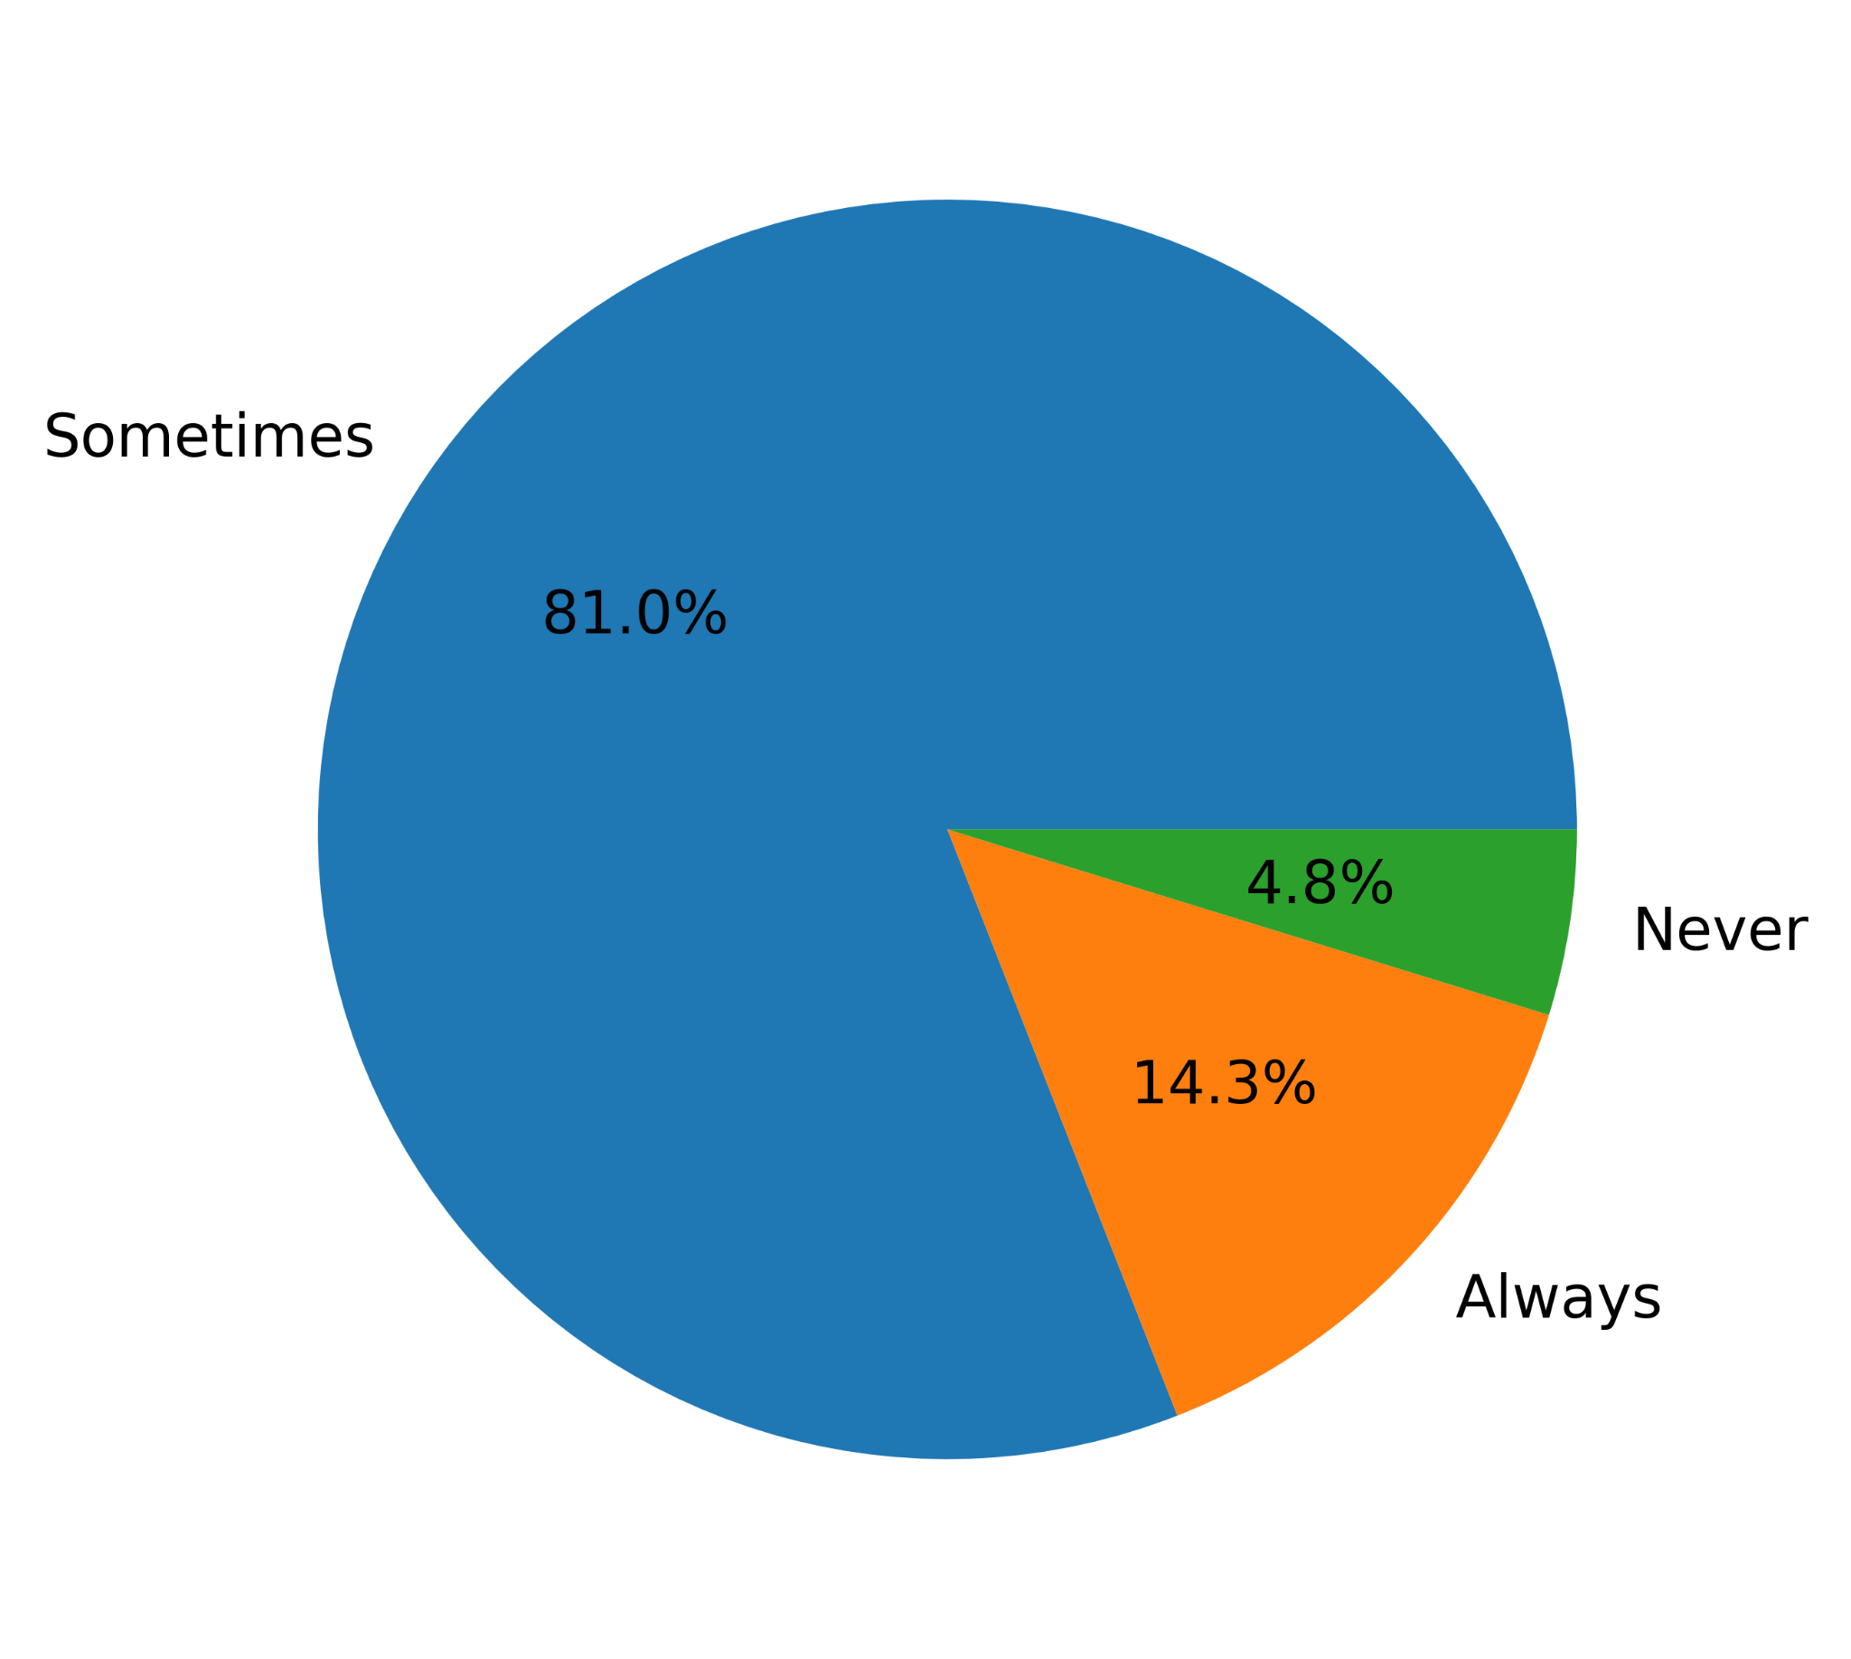

Figure 9. Pie chart statistics of the eighth close-ended question.

My first open-ended question was, “Is it appropriate to penalize students for AI plagiarism? If so, then please mention to what extent and why.”

The positive answers are below:

“Yes. Up to 50% of plagiarized assignment for unoriginal content derived from written articles.” “Yes. It should cause marks deduction.” “Depending on the extent of plagiarism e.g if a student copies 100% from AI then penalize them by giving no marks and so on.” “Of course they should be.” “Yes.” “Yess, I think students should be penalized at a Highest State.” “Yes.” “yes because you cannot go online and just copy-paste your homework!” “Yes, because afterward, they will have a chance to realize the importance of utilizing their brain. However, it might be acceptable to use AI as long as AI ethics are maintained, and it may also depend.” “It's should deduct 50% marks because of plagiarism and the rest of the 50% should be given because they at least tried with AI.” “Yes. Students don't use their own language because of AI.” “Depends.” “Sometimes.” and “Not very much.”

The negative answers are below:

“No.” “No.” “Nope, I don't think so.” “No.” and “Not appropriate.”

The neutral answers are below:

“Not sure about anything.” and “No comments.”

It is evident from the answers that the majority, i.e., 14 participants, agreed to the penalty for AI plagiarism depending on the extent. On the other hand, five disagreed. The other two are neutral. Therefore, this data suggests penalization.

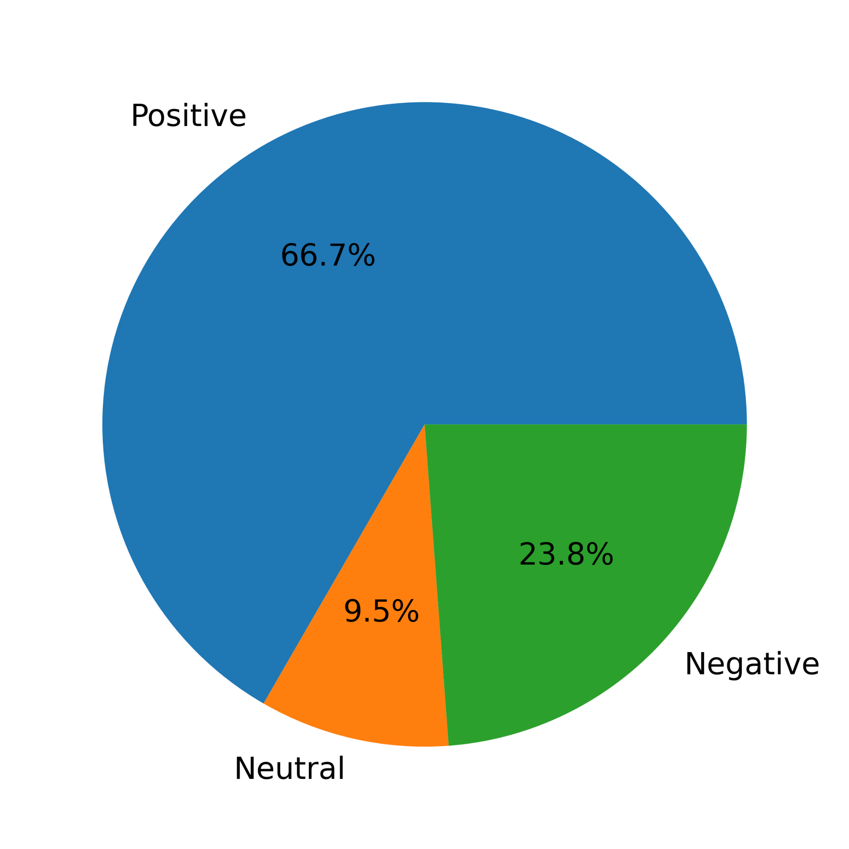

Figure 10. Pie chart statistics of the first open-ended answers emotional inferences.

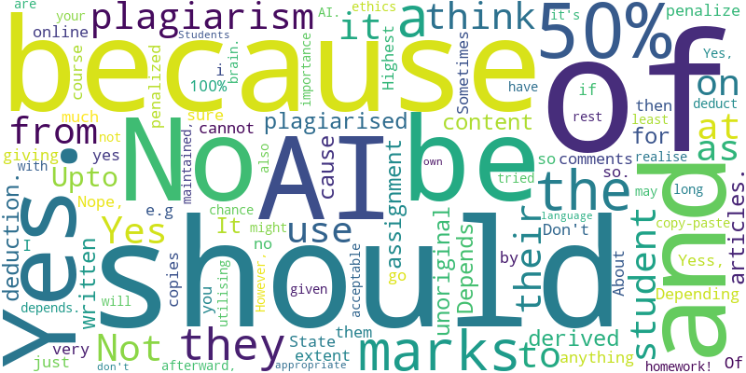

Figure 11. Word cloud of the first open-ended question.

My second open-ended question was, “Please suggest some good rules to fight AI plagiarism in universities.”

The answers about being ethical are below:

“Not being able to copyright from books or articles even though the writing itself has been published.” “He/she should always be honest to himself/herself.” “Students would face marks deduction if AI plagiarism is detected in their work.” “Faculties should be very strict about this and should ensure no students attempts it.” “Teachers should not suggest ChatGPT in class & students should avoid this as much as possible.” “Promote Original Research.” and “Make the students interested about their given topics and building a mind of doing research related to that specific topic.”

The answers about AI detector enforcement are below:

“Need creation AI plagiarism tools.” “By generate new AI soft which can detect AI plagiarism.” “Teachers as well as students should be provided with Turnitin account.” and “Enforce rules against complete plagiarism using AI.”

The answers about giving more classwork are below:

“Teacher should not give a large homework. Homework should be short and based on everyone written homework teacher can take viva.” “Encourage faculty to not give boring assignments.” “Take more class works and group works.” “Class practice.” “Increase open book exams, presentation speech and lab work.” “Presentation Based on All Written Assignments and Peer Review,” “Class tests.” and “Class tests can be a great alternative to fight AI plagiarism. But yet homework or assignments provide enough time to think properly to solve any situation. I think universities or other educational institutions can provide multiple days to submit any creative assignment but students will have to come to their institutions to complete the assignments supervised by TAs.”

The answers about having no ideas are below:

“Not Sure.”

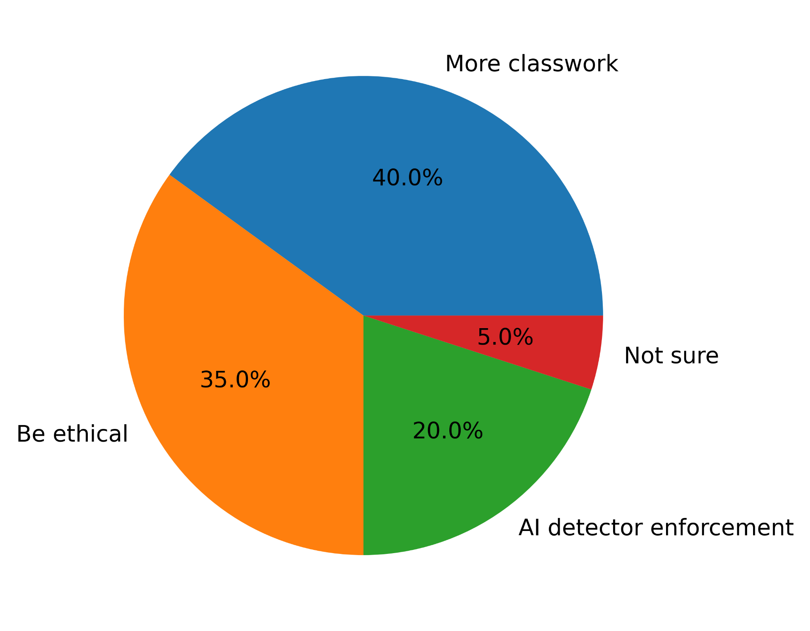

Figure 12. Pie chart statistics of the second open-ended answers analytical inferences.

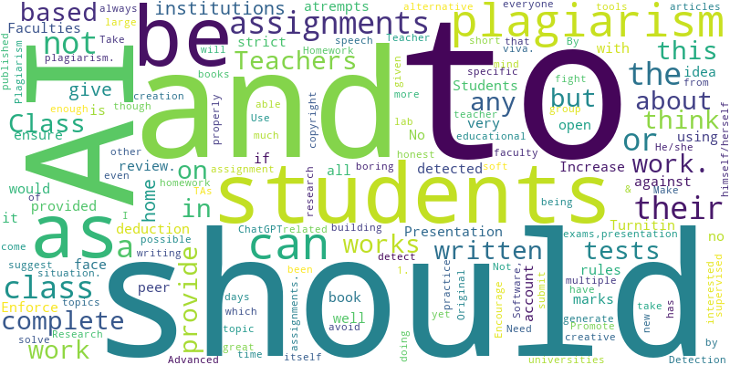

Figure 13. Word cloud of the second open-ended question.

## 4.2.3 Summary of research findings

My primary research work is the heart of this research. All the close-ended and open-ended questionnaires confirm my hypothesis directly or indirectly. Even though the students commit this issue to happen in the first place, they conform to it and suggest remedies. It illustrates how grave the situation is, and all the academia should come forward to fight it. It is evident from the last open-ended answers that the participants made many excellent suggestions regarding fighting AI plagiarism, which every academy should follow.

The answers to the first, second, and third close-ended questions directly confirmed my hypothesis. The answers to the fifth, sixth, and seventh close-ended questions indirectly confirmed my hypothesis. The answers to the first open-ended question directly confirmed my hypothesis, too. The second open-ended question answered indirectly confirmed my hypothesis, too. Though the fourth close-ended question answers do not directly confirm the hypothesis, it motivates us to avoid plagiarism. Also, the answers to the eight close-ended questions do not directly confirm the hypothesis; they acknowledge that AI may have good use rather than cheating and plagiarism. In my last open-ended question, participants, i.e., enrolled university students, suggested class work, ethics, and AI detectors to cope with this modern issue. These suggestions are priceless and perfect in our context. All the academia should implement these and provide Turnitin subscriptions to the teachers.

My secondary research, i.e., reviews of past studies, implies the terrible aspects of AI plagiarism. The first suggested ways to fight, and the second exposed the beneficial parties. After studying them, one can see how students are the sole victims here. With a new tool that contributes to plagiarism, they are wasting their merit. Only the teachers can realize the severity and full impacts. Therefore, all my secondary research confirms my hypothesis.

Students are only using AI for plagiarism. Both primary and secondary research results imply negativity. I could not find a single counterargument instance. They consider it unethical to penalize students too much, considering current education systems lack AI supervision. Therefore, the hypothesis that AI hurts students’ creative capabilities is true.

Chapter 5: Conclusion

# 5.1 Summary

AI detectors have been working like charms recently. Hoover, A. (2024) stated that “Students have submitted more than 22 million papers that may have used generative AI in the past year, new data released by plagiarism detection company Turnitin shows” (para. 1). It is like AI versus AI. We should let the machines do their battle and normalize AI. Then, we will be able to solve new problems unimaginable.

Students should use AI to generate additional study materials to broaden their understanding. With the help of AI, students can do a lot more work. For instance, suppose a student has a test on argumentative essay writing. They can now just go to AI apps and ask them to generate as many sample copies as they can read. In the past, searching the internet for each sample and studying it would take equal time. But now, this search process is omitted, and students can double their study time. It will be unarguably beneficial for the whole of humanity. The brain can work out while the body rests. Just remember the total work will be the same no matter what tools people use.

# 5.2 Value of this Study

This study is precious in today’s context. All the academies of the world can benefit from its findings. After learning the research, they can add new rules to the code of conduct book. AI software and detection software development can help fight against their misusage.

# 5.3 Limitations of this Study

This study had a few limitations. Finding participants was on top. The duration was also scarce as the broad topic encompasses various fields. I needed more information for the quantitative research as this topic is relatively new.

# 5.4 Recommendations

By the time this research ends, new literature will emerge discussing this problem. With all the quantitative research, this work can progress even further.

References

Boser, U. (2024, February 26). How Keystrokes Could Curb ChatGPT Plagiarism. *Forbes*. <https://www.forbes.com/sites/ulrichboser/2024/02/26/how-keystrokes-could-curb-chatgpt-plagiarism/?sh=441138df709f>

Fore, P. (2023, October 25). A majority of educators are concerned about how AI may boost cheating and plagiarism but think it will also boost accessibility, according to a new report. *Fortune*. <https://fortune.com/education/articles/imagine-learning-digital-curriculum-2023-educator-ai-report/>

Habib, S., Vogel, T., Anli, X., & Thorne, E. (2024). How does generative artificial intelligence impact student creativity? *Journal of Creativity*, 34(1), 100072. <https://doi.org/10.1016/j.yjoc.2023.100072>

Hoover, A. (2024, April 9). Students are likely writing millions of papers with AI. *Wired*. <https://www.wired.com/story/student-papers-generative-ai-turnitin/>

Marrone, R., Taddeo, V., & Hill, G. (2022). Creativity and Artificial Intelligence—A Student Perspective. *Journal of Intelligence*, 10(3), 65. <https://doi.org/10.3390/jintelligence10030065>

Marshall, J. (2023, July 5). As AI cheating booms, so does the industry detecting it: ‘We couldn’t keep up with demand.’ *The Guardian*. <https://www.theguardian.com/technology/2023/jul/05/as-ai-cheating-booms-so-does-the-industry-detecting-it-we-couldnt-keep-up-with-demand>

Morgan, J. (2023, September 27). ‘Get out of plagiarism rut’ and teach students how to use AI. *Times Higher Education*. <https://www.timeshighereducation.com/news/get-out-plagiarism-rut-and-teach-students-how-use-ai>

Singer, N. (2023, December 13). Cheating Fears Over Chatbots Were Overblown, New Research Suggests. *The New York Times*. <https://www.nytimes.com/2023/12/13/technology/chatbot-cheating-schools-students.html>

Singleton, T. (2024, May 28). AI products like ChatGPT much hyped but not much used, study says. *BBC News*. <https://www.bbc.com/news/articles/c511x4g7x7jo>

Topinka, R. (2024, February 13). The software says my student cheated using AI. They say they’re innocent. Who do I believe? *The Guardian*. <https://www.theguardian.com/commentisfree/2024/feb/13/software-student-cheated-combat-ai>

Vaidhyanathan, S. (2023, May 19). My students are using AI to cheat. Here’s why it’s a teachable moment. *The Guardian*. <https://www.theguardian.com/technology/2023/may/18/ai-cheating-teaching-chatgpt-students-college-university>

Questionnaire

**Data Collection Technique: Survey**

*A SURVEY OF UNIVERSITY STUDENTS*

This survey is a part of my research paper titled “AI Usage by Students for Creativity.” This survey intends to collect university students’ views to support my research paper. It will only take 5-10 minutes to answer the questions.

***Instructions:***

* *Give* (**√**) *beside the answer for multiple choices.*

* *Write your answer in the text boxes for open-ended questions (given under the questions)*

***Thank you for participating in this survey!***

**Basic Questions**

1. You are

* Male
* Female
* Other

1. **THEME: Statistics**

Question 1 A

Have you ever plagiarized homework by using AI and got away with it?

* Always
* Sometimes
* Never
* No comments

1. **THEME: Motivation**

Question 2 B

Has overall student plagiarism increased after AI came?

* Increasing rapidly
* Increased
* Constant
* Decreased
* Decreasing rapidly

1. **THEME: Hypotheses validity**

Question 3 C

Do you agree that AI hurts students’ creative capabilities?

* Strongly agree
* Yes
* Neutral
* No
* Strongly disagree

1. **THEME: Fact-checking**

Question 4 D

Can students increase their creativity by utilizing AI somehow?

* Always
* Sometimes
* Never
* No comments

1. **THEME: Ethical dilemma**

Question 5 E

Do you think it is appropriate to penalize students for AI plagiarism? If so, then please mention to what extent and why.

_____________________________________________________________________________

1. **THEME: Possible solutions**

Question 6 F

Do you agree that additional class tests should replace homework?

* Strongly agree
* Yes
* Neutral
* No
* Strongly disagree

Question 7 F

Do you agree that students’ homework should become classwork to avoid AI plagiarism?

* Strongly agree
* Agree
* Neutral
* Disagree
* Strongly disagree

Question 8 F

Do you agree that universities should teach ethics related to AI usage?

* Strongly agree
* Agree
* Neutral
* Disagree
* Strongly disagree

Question 9 F

Please suggest some good rules to fight AI plagiarism in universities.

_____________________________________________________________________________

1. **THEME: Conclusion**

Question 10 G

Should students use AI at all?

* Always
* Sometimes
* Never
* No comments